Experience

General Manager CTU CONSULTANTS

December 2019-Present
General Manager 14 years experienced providing administrative support to a cew of over 25 interfacing with clients, architects, engineers, subcontractors, and suppliers utilizing strong multi-tasking skills simultaneously managing multiple projects and schedules

Project coordinator C.R.S. Inc.

February 2010-November 2019

Oversee a project from start to finish

Manage day-to-day activities

Develop project schedules and budgets

Analyze data to ensure the project is completed on time within budget to the highest quality standards
Prioritize communication and conflict resolution to ensure stakeholders are satisfied with the progress and outcome of ongoing projects
Provide project progress reports and updates throughout the project to keep stakeholders informed of project status
Handle construction collections, complete subcontractor releases, supplier releases, vendor releases, conditional releases, unconditional releases, conditional final, unconditional final, skip tracing, legal, prelim, mechanics liens, record mechanics liens, lien perfection preparation, CSLB bond forms, small claims 100 form construction collections

EDUCATION

Visual communications = AA Business Admin
AIU ONline University
May 2008
Deans List 2008

KEY SKILLS AND CHARACTERISTICS
Strong Interpersonal and Communication Skills Construction Software MS Office Suite Ability to work collaboratively as part of a team Meticulous attention to detail Strong Leadership Problem Solving Excellent organization skills Work well under pressure
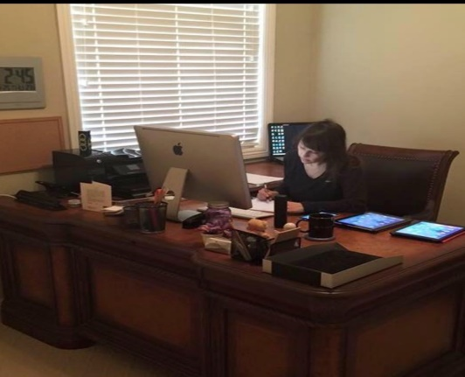

LyN Nauenburg
  - general manager

OVErview
Performing daily operations efficiently onboarding new independent construction consultants providing administrative support reducing operating costs while maximizing profit

CONTACT
lyns_success@email.com
www.linkedin.com/in/lyn24
(760) 238-8247
72877 Dinah Shore Drive 103-158
Rancho Mirage, CA 92270

https://dmslln3.wixsite.com/llnpc24

